Lake Forest Estates
Annual Meeting
April 28, 2024 lakeforest63670@gmail.com
Website: lakeforestestatesmo.com

Call to order- Jim Donze 2:00 pm
Jim Donze- President, Tim Uding- Vice-President, Rose Kastrup- Treasurer, Greg Stephenson- Secretary, Kent Orrick, and Dennis Lea attended.

Determination of Quorum-
• Jim Donze surveyed the residents in attendance to determine if a quorum was present. It was determined that a quorum of residents was present.
Announcements:
Jim Donze welcomed everyone to the Lake Forest 2024 Annual meeting and read the following statement:
Good afternoon…on behalf of the Lake Forest Board of Directors welcome to the 2024 annual business meeting. Prior to starting with the agenda today I need to comment on pending human resource concerns received by the Board of Directors. Please understand the Board of Directors will not entertain any comments from the floor regarding the work performance of any Lake Forest employee. We take this position to protect the rights of our employees, and to allow the Board of Directors ample time to investigate any concerns brought to our attention. Please note we do have a process for residents to register their concerns with the board via the Lake Forest website. If you have any questions about this process, I’ll be happy to visit with you after the meeting today.
Jim Donze then covered the following:
- Review of the Agenda
- Introduction of the Board and noted that Mark Wiegert is out of town.
- Review of Board Vacancies/Terms o There are (2) 3-year term Board seats up for election.
  - Jim Donze said those who had not voted were welcome to cast their ballots now.
- Introduction of Board Candidates – Kent Orrick, Mark Wiegert, Dave Evelsizer, and Todd Jokerst.
- Other Nominations – Jim Donze called for other nominations from the floor.
  - There being no other nominations from the floor Greg Stephenson motioned those nominations be closed. Seconded by Tim Uding. Motion passed with all in favor.

Business Session Approval of Minutes-
• Motion to approve the Annual Minutes 2023 made by Tim Uding. Seconded by Rose Kastrup. Motion passed with all in favor.

Treasurers Report- Rose Kastrup

Lake Forest Estates Annual Meeting
Treasurer’s Report
CURRENT ASSETS
As of APRIL 26,2024
CASH= (Regular Checking + General Fund) $ 334,785.17
INVESTMENTS = $ 610,015.00
___________________________________________________________________________________________
TOTAL Current Assets= $ 974,631.02
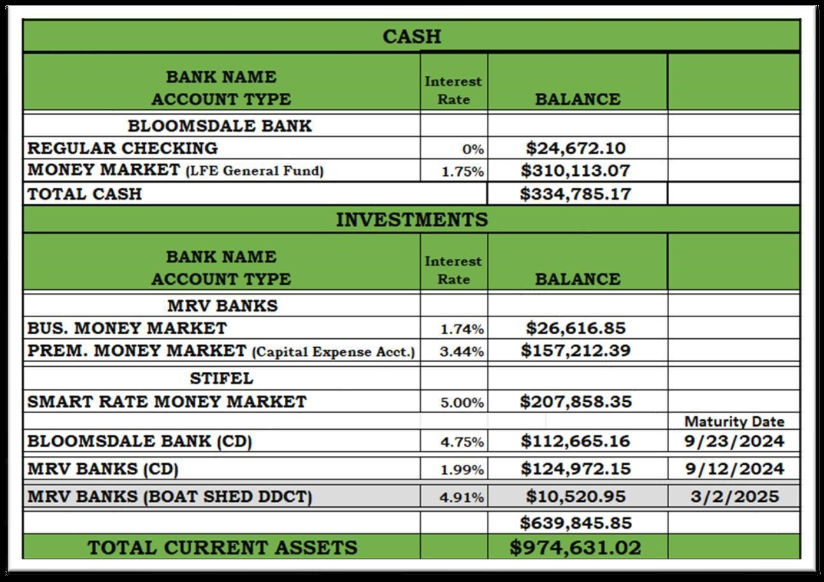

Motion to approve the Treasurer’s report was made by Greg Stephenson. Seconded by Tim Uding. Motion passed with all in favor.

Community Managers Report:

Last years projects were:

- Fresh paint inside of the Hall.
- New roof and gutters for the Club House
- Replaced a culvert pipe on Cedar Circle and repaved the area.
- Installation of a handicap ramp at the Post Office
- Handrails around the Post Office porch • Handrails at the boat ramp on Tall Pine
- Marina Bridge handrail installed.
- Various road and ditch improvements
- Internet provided to camera areas for security to better view.
- A/C unit installed for office area.

All the equipment and vehicles are kept in good order and running well. The trees, grass, and roads are in good condition. John and I keep up with all the maintenance issues. Most are taken care of in house. We do very little outsourcing to save on costs.

Committees:

Public Works: Don Kuehn

There are no large projects underway. Most is covered in Tom’s report. Jim Donze brought up the speed limit and asked the residents if they were interested in lowering the speed limit. Jim said we are going to be purchasing new signs and now would be the time to change it if the residents wanted it lowered. There was discussion about lowering the speed limit. Don Kuehn gave some history on how the speed limit was established at 25 mph. The residents present wanted the speed limit to remain at 25 mph.
Todd Jokerst asked how speed bump locations were determined. Jim Donze said it was based on complaints of speeding by residents.

Mark Basler gave a brief update on the Sewer project. Mark was unable to take any questions but encouraged residents to attend the Water Board meeting which is the second Thursday of every month right before the Lake Forest Board meeting.

Planning and Finance: Rose Kastrup

FUTURE CAPITAL IMPROVEMENT PROJECTED EXPENSES PLAN:
- COMMUNITY CENTER ROOF (2023)- Completed
Total Expense: $10000.00
- POOL UPGRADES (2024) - $ 75,000.00 GF or CD
- BOAT SLIPS (2024) - $120,000.00 GF or CD
- HALL IMPROVEMENTS - $0.00
o Paid for by Fund raising and Donations
➢ DREDGING AND ROAD REPAIRS ESTIMATED EXPENSES (2024-2027)-
$750,000.00 MM CEA o Dredging- $250,000.00 o Road Repairs / Resurfacing- $500,000.00
ITEMS TO BE ADDRESSED:
Equipment Repair(Truck bed repair/rebuild (Truck bed repair/rebuild) $13,000.00.
Community Center Repairs (Soffit) $ 5,000.00- Completed
Swimming Pool Other Supplies (9 Umbrellas) $ 2,500.00
Playground Equipment Purchases (swings) $ 5,000.00 Roads – Street Signs (Purchase of street signs) $ 4,000.00 Bridges (Replace remaining handrails) $ 15,000.00.
Security- (Flock Camera yearly fee) Cameras $ 800.00 Party (Octoberfest) $ 1,000.00

ACC: Tom Duro

There were 30 permits issued over the year, most of which were for landscaping. There were some patios, driveways, and irrigation systems as well.

Lakes: Chuck Easley and Ray Joggerst

The code on the locks at the ramps has been changed for 2024. The code is on the back of the 2024 boat registration stickers. Please do not share this code with anyone or post it on any social media platform. We have found the boat ramp cables down a few times. Please make sure and put these back up and secured after launching and loading your boat.
We have not stocked fish yet this year and may not, since there is a question about which lake will be lowered first. Once we know that info, we will reevaluate stocking.
Contrary to the sign at the marina boat ramp, there is a slot limit for bass in force. The limit includes a requirement that all bass between 12 inches and 15 inches be returned to the lake unharmed. The slot limit will help increase the size of our Bass and improve the overall quality of the bass population in the long term. We are asking fishermen to keep bass less than 12 inches in length and although it is allowed to keep the over 15-inch bass, it would be best, when possible, to return the over 15-inch fish to the lake. With the upcoming sewer project and associated lowering of the lakes, having a decent population of larger bass during the process will help ensure a healthy bass population exists during and after the process.
The Pancake breakfast was held in conjunction with the Easter egg hunt and after expenses, we netted $651 dollars. Thanks to all who volunteered to help and those who came out in support of our Kids Fishing Day.
June 8th will be the Kids Fishing Day for kids 15 years old and under and will be held on Lake Susan again this year. All are welcome to come and fish but the Derby is only for those kids 15 years and under. As a reminder, non-residents must always be accompanied by a resident/property owner while fishing in the lakes. This includes family members who don’t reside in LFE and contractors working on your property.
With the boating season fast approaching, now is a good time to review all the lake rules. A few high lights from those rules include:
{To utilize the lakes, boats and trailers must have and display a current LFE boat sticker, be properly registered with the state, and display the boat registration number, current registration tab and motor registration sticker (not applicable to electric trolling motors).
If you are pulling a skier or tube, in addition to the boat operator, there MUST be an observer in the boat and an orange flag displayed. Skiers/tubers are required to wear a life vest.
Additionally, if you are swimming, floating, or operating a non-powered boat (paddleboat, kayak, canoe, etc.) on the main lake portion of Lake Anne, you must stay within 25 feet of the shoreline. }
These rules as well as the remainder of the lake rules are in place to ensure the safety of everyone using our lakes. Please review the lake rules and abide by them.
The otters have returned, although only a couple have been seen. We encourage anyone seeing them on any of our lakes to report this to either Ray or Chuck. Otters are cute but they pose a danger to people and pets as well as causing damage to property and they negatively affect the fish populations in the lakes. Last year, they appeared to have left once boats became common on the lake, we believe the same will happen this year. If they don’t leave on their own, we will take steps to remove them. We held a bass fishing tournament this spring in support of the Good Friday fish fry. The fishing was tough, but we had a good turnout for it. Thanks to those who participated in the event.
We encourage those with lakeside properties to use fertilizers with a very low middle number (zero is ideal) and not fertilize any areas within 25 feet of their shoreline. We also want to remind homeowners (or their yard services) to not mow in a direction that blows grass clippings or yard waste into the lake.
If homeowners take these simple steps, it will help reduce the number and size of algae blooms.

Security - Dave Evelsizer

Cameras are all connected via Wi-Fi and are easily visible on a single pane which makes reviewing the recordings very easy.

Rules- Dave Evelsizer

Jim Donze said that he had asked Dave to look at the rules covering dogs and send them to the Board. We are having a lot of complaints about dogs chasing residents and other issues. Also, our Attorney has said that a fence is a fence regardless of if it’s a wireless fence for dogs and the Board has the authority to make determinations on those. The Board will be determining how close these fences can come to the road and property lines. Jim went on to reiterate that only two pets per household.
Jim also said that the Board is looking at the commercial vehicle rule and what can be done to reach some middle ground on that rule. The current rule was written in the 1970’s when a lot of people did not get a company vehicle as a perk.

Hall – Tom Duro

Last year there were 159 usages of the hall between the Women’s Garden Club, Women’s Card Club, Men’s Card Club, Happy Hour, Disaster Response Team (Bob Bach), and there were 48 rentals for Wedding Showers Etc.
Jim Donze said that there is an Ad Hoc committee with 4 or 5 people that are looking at improvements to the Hall. They added cushions for the deck chairs and a box to store them. They will be presenting fund-raising ideas to the Board for these improvements. Jim also mentioned that we want to keep the fundraising to a minimum until the restrooms for the All Purpose Courts are funded. Jim asked Tim Uding to give an update on that.
Tim said that there will be two restrooms on the left side of the entrance to the All Purpose Courts. Kate
Pepin has been selling pavers that can be engraved with a name and hopefully we can cover the cost of the restrooms with fundraising. The hope is that by the end of summer we can have the restrooms completed.

Entertainment- Linsey Winkler

Jim Donze thanked Lindsey for everything that she does for the Entertainment Committee.

March 29th- Restroom Fundraiser Fish Fry

March 30th- Pancake Breakfast/ Easter Egg Hunt 8-11am (egg hunt starts at 10)

May 18th- Cornhole Tournament - Belle On Wheels food truck

June 8th- Kid’s Fishing Tournament

Summer Concert Series:
*June 22nd - Wings of Eagles 6-10pm, - Karl’s Kitchen reserved
*July 20th - Dave Caputo 7-10pm
*August 24th - Crossroads 6-9pm

July 4th-Kid’s 4th of July parade
July 5th- Fireworks

September 14th - Dockside Happy Hour

September 28th- Oktoberfest

October 12th-Bocce Ball Tournament

October 26th – Halloween

December 14th - Kid’s Christmas party

December 22nd - Santa parade

New Year’s Eve - 6-11pm

Pool – Tom Duro

Pool preparation for the 24th of May opening is going well. We have 7 lifeguards hired from lake forest. Tom asked everyone to pay attention to the rules when using the pool.

A resident asked a question about the $75,000 that was earmarked for pool improvement. Tom explained that would be the cost of applying a new epoxy coating to the entire pool, painting and caulking the pool. Jim Donze said for now we are holding off and will look at this later, but we know eventually it will need to be done.

Boat Sheds – Robert Wolk

One section of roofing has been replaced on some of the older sheds.
Get your stickers on your trailers. New yellow stickers are available, and they are free.
Greg Stephenson pointed out that Lake Forest does not have anything to do with the Boatsheds in terms of dues, insurance, or taxes. The funds do flow through Lake Forest for accounting purposes but that is the extent of Lake Forest Estates involvement.

Curb Appeal – Tom Duro

Tom said that John has everything mulched and things are looking good. Tom thanked Mike Abts, John Heitkamp and Nancy Brown for keeping the marina flower beds looking good. If you would like to take care of one of the flower beds in Lake Forest let Tom know.

ATV Committee- Greg Stephenson

No report on the trails but we need some volunteers who can help with the trails.

Website- Megan Jokerst

The website has a lot of useful resources for the community. If you have photos and entertainment events, please send those to the office.

Other Business

Tom Duro said that Lake Forest has negotiated a new 5-year contract with Republic Services. This contract has an automatic increase of 5% every year for both regular residents and seniors. Tom said our rates are considerably lower than what people are paying in town.

Jim Donze said that Fireworks will be on the 5th of July.

Jim also said that the Board has received several emails prior to the Annual meeting as usual. Also, Jim noted that Kent Orrick has been doing a great job responding to emails sent to lfeboard@gmail.com. Jim knows it’s important to get answers out to everyone and he thanked Kent for taking that job on.

We had an email request to put the trash can back at Lake Forest and Tall Pines where the boat ramp and picnic area is located. Jim said that we would not be putting that can back because the only thing that is put in there is dog poop and we are not going to have Tom and John emptying that out anymore.

Jim Donze said there was a request to install a pool via email. There are no pools allowed in Lake Forest according to our rules and regulations.

Jim Donze also said that there will be more traffic than normal next weekend. We have been working with the Schweiss family farm who is hosting a fund raiser for a family that has cancer. Some traffic will be using the back entrance to the farm by the marina.

For anyone who has not signed up for the text messaging alerts that go out to all residents: Send this message @skilfe to the following number 81010 and you will be automatically added to the list. Contact Greg Stephenson at 618-593-5353 if you have an issue with this.

Also, the Board’s email address lfeboard@gmail.com is automatically forwarded to all Board members. You will get a thank you email letting you know your email was received. The Board will respond in a timely manner to your email. Keep in mind that some issues or concerns may take time for the Board to resolve before you receive a response.

Open Forum

A resident asked about getting a permit to shoot the geese. Jim Donze said that yes that has been done before but it must go through DNR and its probably not going to happen anytime soon.

A question was asked about golf carts out in the driveway and if we could change that rule. Jim Donze said we can look at that, but all the rules are there for a reason.

Vickie Wibbenmeyer thanked the Board, Tom, and John for everything that they do for the community.

Rose Kastrup mentioned the house keeping emails that Megan has been sending out of the office from time to time. A resident asked if we could post those reminders for residents who do not have email. Jim said that yes we can find a place to post those.

Wayne talked about the geese and the license that we had to get several years ago and asked the Board to look into it. Wayne also thanked Megan Jokerst for everything that she does for us.

Jim Donze thanked Wayne Balser for everything he does in the community as well as all the other volunteers.

Election Results

Jim Donze asked for the election results from the Chair of the Election Committee Wayne Basler.

Jim announced that Todd Jokerst and Mark Wiegert will be on the Board. Jim thanked Kent Orrick for his time on the Board and his service to the community.

Adjournment – Motion to adjourn was made by Greg Stephenson. Seconded by Rose Kastrup. `Motion passed with all in favor.

